**Environment Canada Climate Data Reader**

Zhiqiang Yu, [hawklorry@gmail.com](mailto:hawklorry@gmail.com)

**What We Have**

In Canada, Environment Canada is the major source of the climate data (precipitation and temperature). The climate data could be downloaded from Environment Canada website ([http://climate.weather.gc.ca](http://climate.weather.gc.ca/)) for each year in CSV format which contains 27 columns data. To be used in ArcSWAT or SWAT, these files must be processed in following way:

1. Extract min and max temperature and total precipitation from each file;
2. Combine the data of different years from the same station into one dbf or txt file in a format required by ArcSWAT.

Let’s take a look. If 5 climate stations are located in/around the study watershed and the simulation period is 20 years, total 5*20 = 100 CSV files need to be downloaded first and then be processed into 5 dbf/txt files. It may take one or two days to finish this work. No modeler wants this.

Besides time consuming, this process is also error-prone. Large amount of files will be process in a same way. The brain and eye is easy to become tired. Wrong file may be processed or the same file may be processed twice. And the most important is that it’s difficult to find these errors. Modeler usually never check the climate data again after they are there, which leave it impossible to figure out climate data related problems in the model.

**What We Could Have**

Since the climate data preparation process involves many repeated work, a program is the natural solution. Select stations, click a button and then go to get a coffee. All the files are ready when you get back. Ideally? Yes, that’s the “Environment Canada Climate Data Reader” is trying to do.

Environment Canada Climate Data Reader, or just call it reader, is a .NET windows program designed to download climate data from Environment Canada and generate result files in a specific format (of course, it supports ArcSWAT dbf and txt format). With it, you could enjoy your coffee when doing work☺

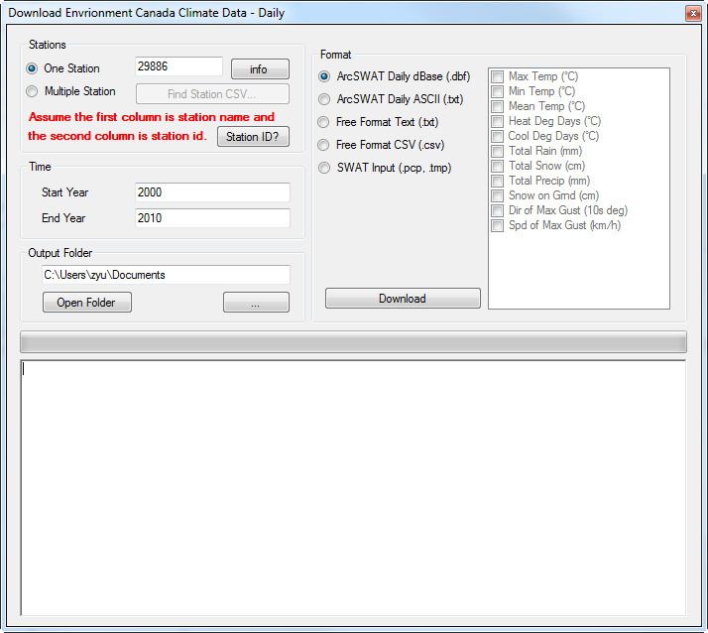

**Quick Guide**

1. Give Stations – Which stations will be used?

Station ID is the unique ID used by Environment Canada to identify each climate station. Before using reader, these IDs must be retrieved based on station name. If you don’t how to get the station id, just hit  and a short tutorial will show you how to do that.

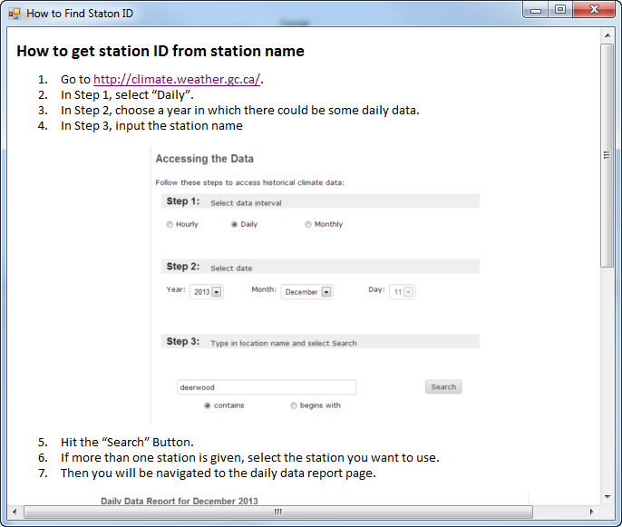

Already got station IDs? Let’s give the ID(s) to the reader first.

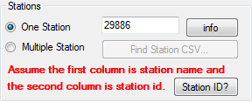

1. Only got one station? Good, just select  option and input the station id in the box. Want to know the information of this station? Hit  to check basic information of this station (to make sure correction station is used).

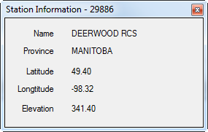

1. Got more than on stations? That’s normal. First prepare a csv file in Excel or any test editor, in which the first column is the station name and the second column is station id. It may look like this:

*name,id*

*deerwood,29886*

CSV file is ready? Select  option and hit  to load the file.

1. Give Time Range – What’s your simulation period?

The simulation period may or may not be decided yet. No problem, just make it longer. ArcSWAT and SWAT would read the right data based on date.

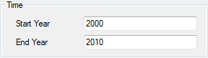

1. Select an Output Folder – Where do you want to save the result files?

The default output folder is the my document folder. Hit  if you don’t like this.  will open the given folder, which will allow you check the result files.

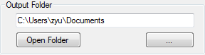

1. Select an Output Format and Data Fields – What format do you prefer and Which data do you like?

Want to just use climate data in ArcSWAT? No problem, just select C:\Users\zyu\AppData\Local\Temp\SNAGHTML189f5f1.PNG or  and you are good to go (only min and max temperature and total precipitation will be exported).

Want some free air and do some analysis on the data? No problem, select  or  and select any climate data you want in the list.

Want the final SWAT format? Yes, for people who don’t use ArcSWAT, just select (only min and max temperature and total precipitation will be exported).

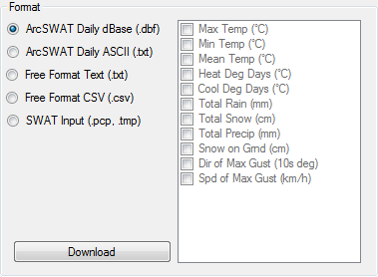

1. Start Download and Drink Coffee

Ready? Hit  to start the work. Progress message will be given on the bottom.

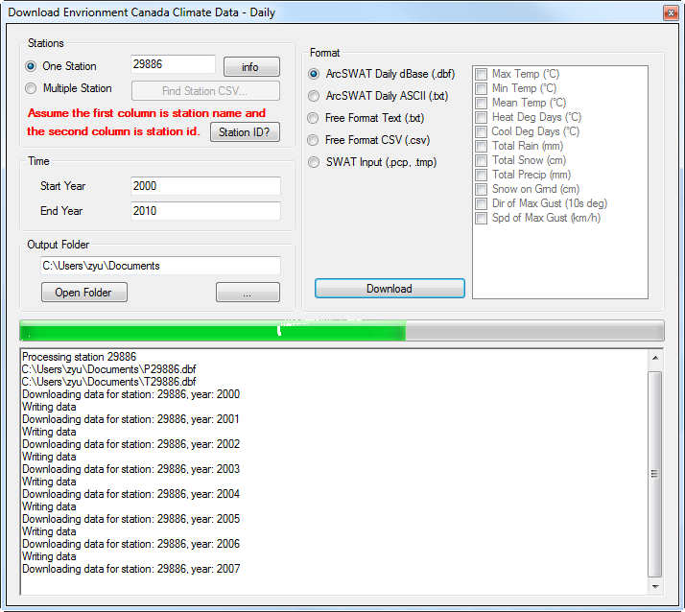

When you see 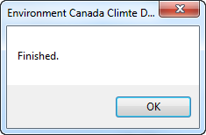, it’s done.

1. Check Result Files

Curious about the results? Hit  to open the output folder and open the result files. You may want to know the name convention for different format.

1. C:\Users\zyu\AppData\Local\Temp\SNAGHTML189f5f1.PNGP[Station ID].dbf for precipitation and T[Station ID].dbf for temperature, e.g. P29886.dbf and T29886.dbf.
2.  P[Station ID].txt for precipitation and T[Station ID].txt for temperature, e.g. P29886.txt and T29886.txt.
3.  [Station ID].txt, e.g. 29886.txt.
4. [Station ID].csv, e.g. 29886.csv.
5. pcp1.pcp for precipitation and tmp1.tmp for temperature.